1. **Agenda**:
   1. Whether we should take a trade based on Rewards.
2. 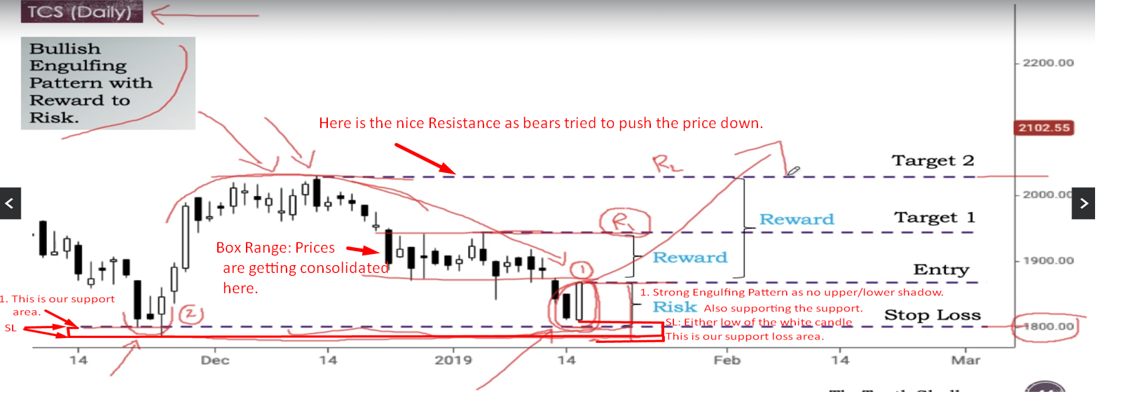
3. A graph with lines and numbers

   Description automatically generated